DASCH Plug-In for VStar

DASCHObservationSource is a VStar observation source plug-in tool which reads DASCH (Digital Access to a Sky Century @ Harvard) data from an input source in tab-delimited “Starbase table” (.txt)) format. See bugs-and-features #439 on SourceForge for VStar. More information is available at http://dasch.rc.fas.harvard.edu/project.php.

Install the DASCH plug-in by going to the Tool menu and selecting Plug-in Manager. AAVSO login is required. Scroll to and select DASCH file reader and click on Install. After installation, restart VStar.

To obtain a DASCH data file, go to the web page http://dasch.rc.fas.harvard.edu/lightcurve.php
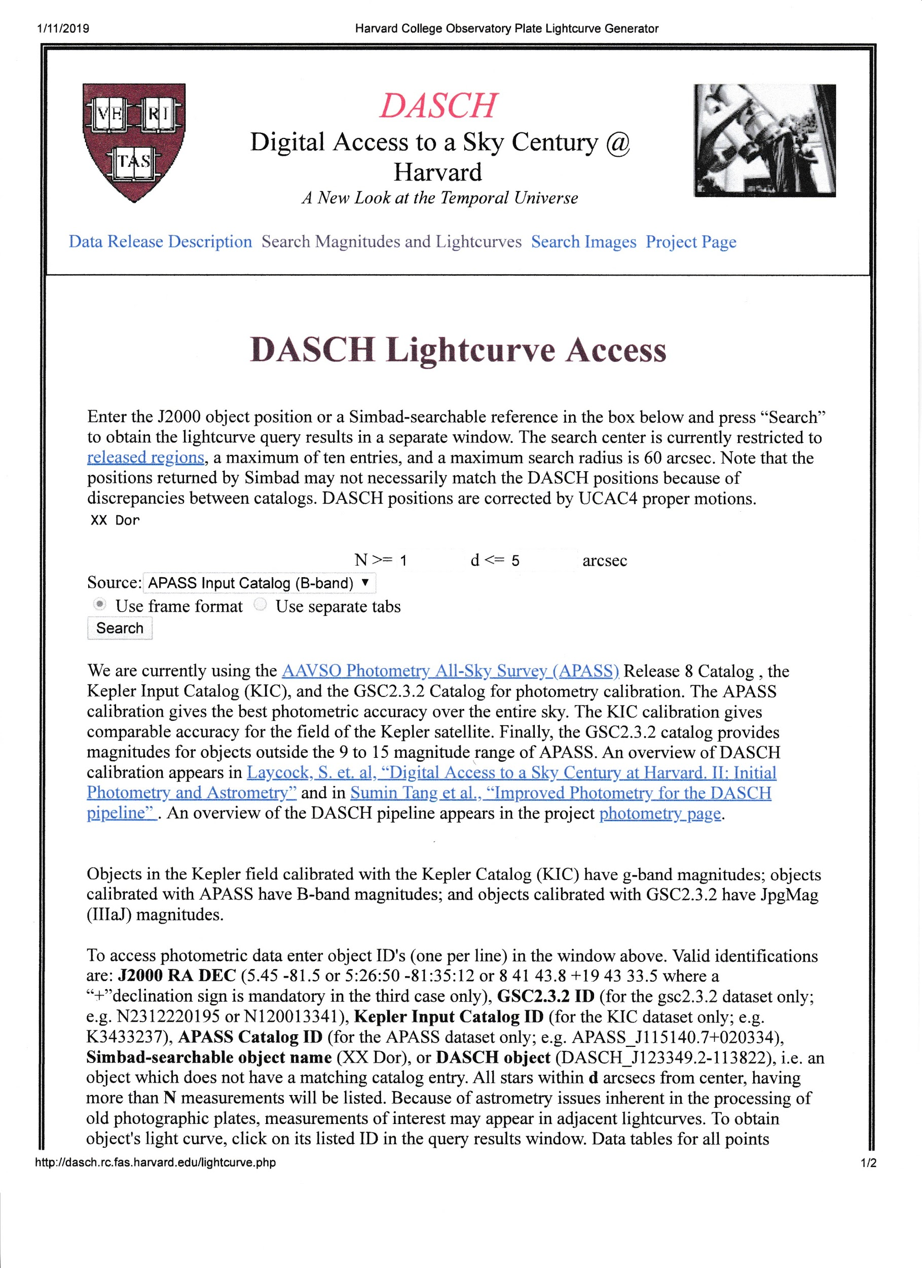
Enter a J2000 object position or a SIMBAD-searchable reference in the box and press “Search” to deliver the query results in a separate window.

As an example, entering "XX Dor” tells the search facility to search for variable stars using the APASS Input Catalog (B-band) for that object. Other catalogs include the Kepler Input Catalog (KIC), DASCH object, and GSC2.3.2 catalog. Additionally, J2000 RA/DEC coordinates (e.g., 8 41 43.8 +19 43 33.5) are valid identifications. The resulting window containing three frames is produced.

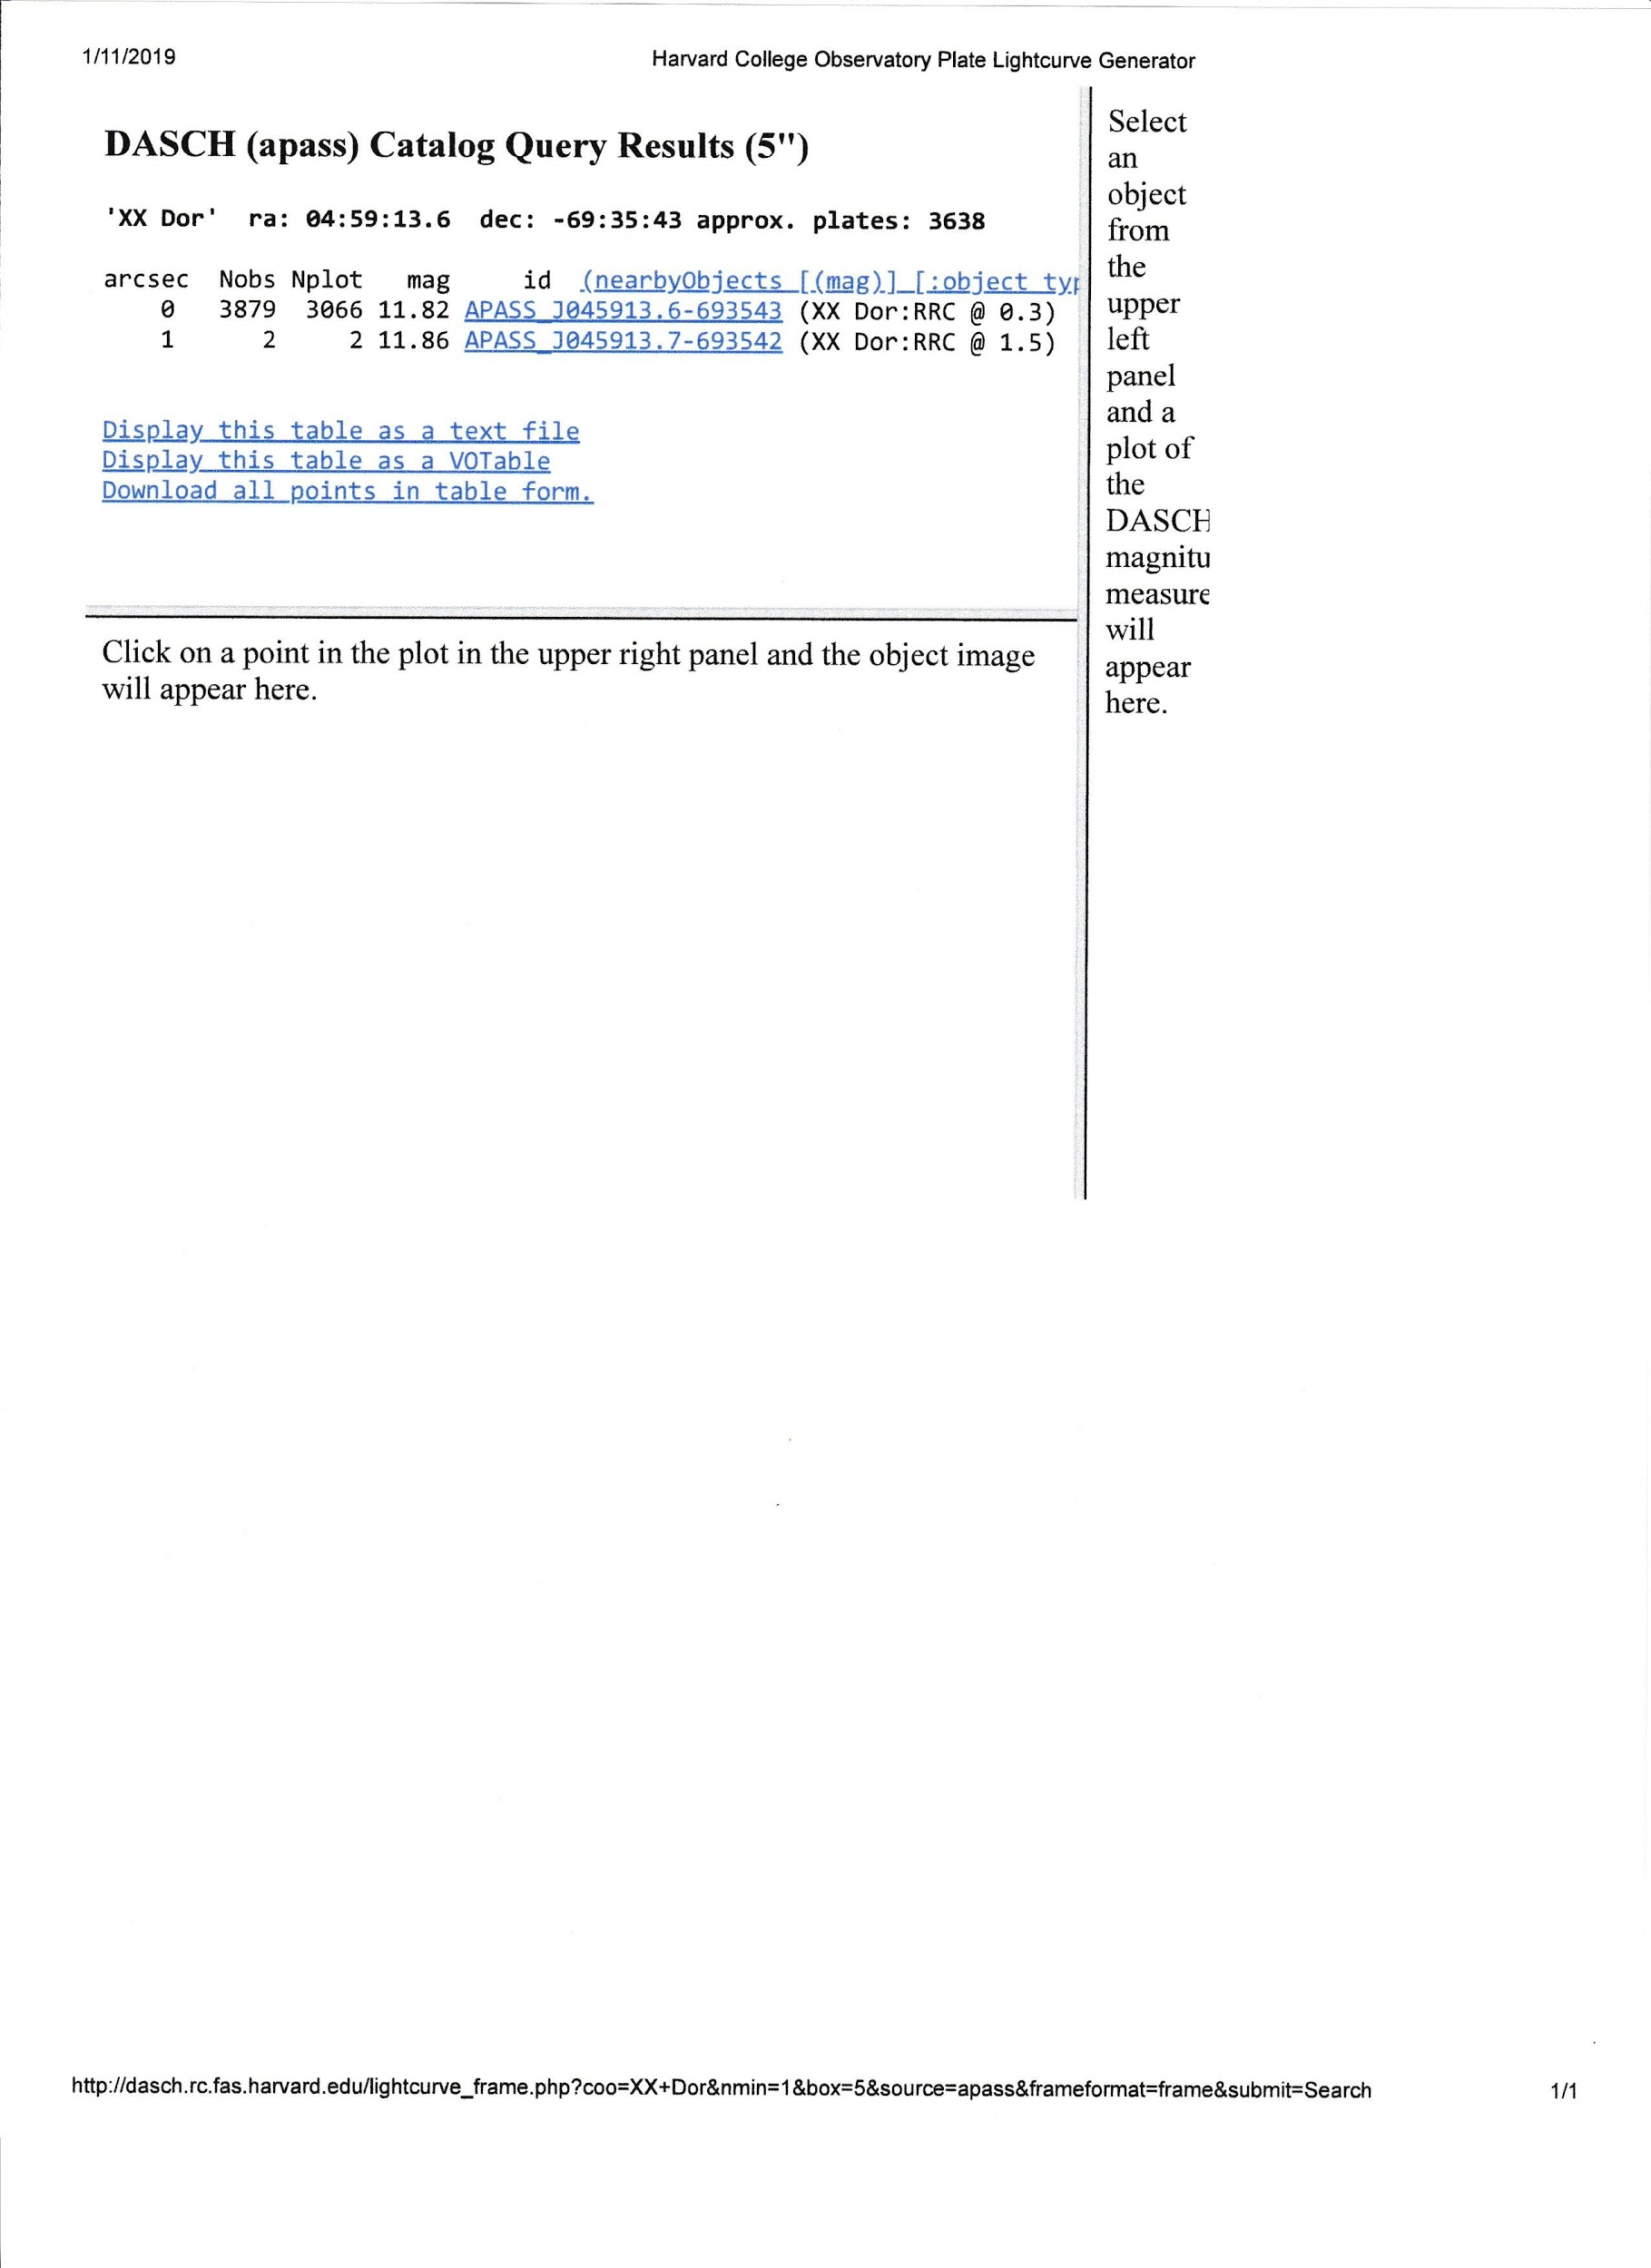
In the top left hand frame, three sets of results and some display / download options are shown. Choose the option “Download all points in table form”, and the resultant page lists several file options (A - H) for each of the three result sets.

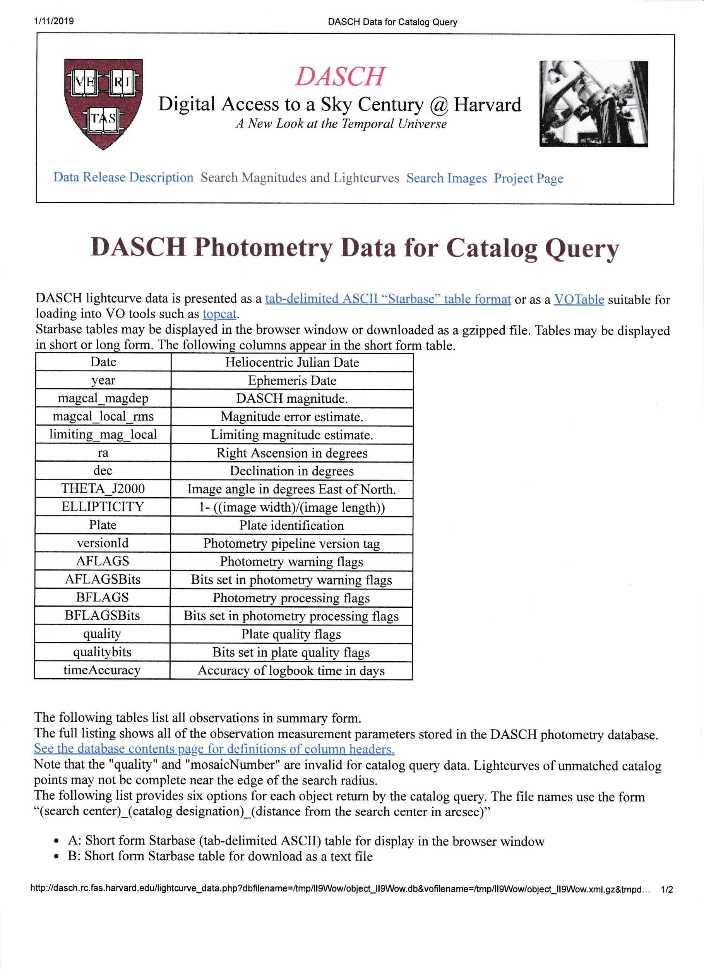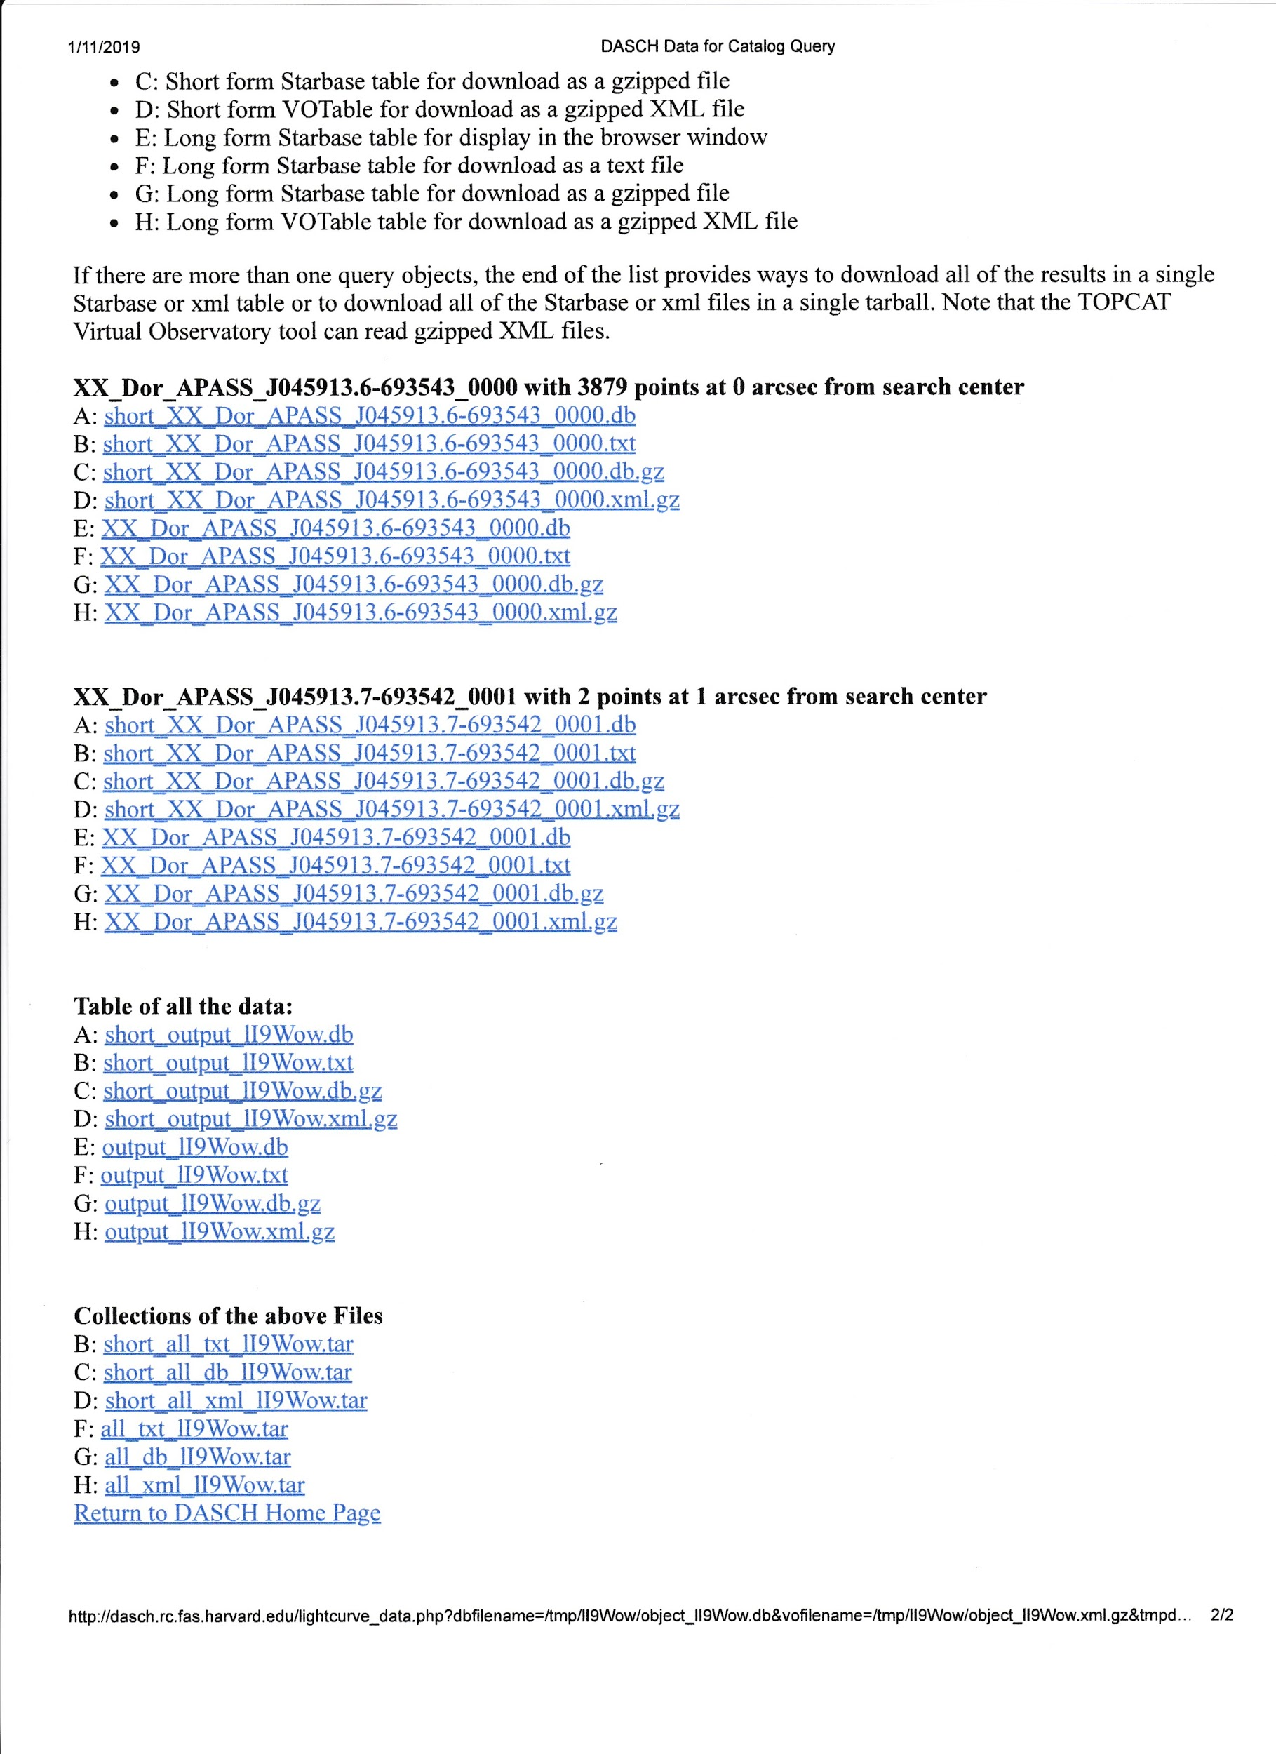
This plug-in is designed to read files of type A, such as “short_XX_Dor_APASS_J045913.6-693543_0000.db".

The plug-in can read this either as a local file on your PC or Mac (once you download it), or as the appropriate URL, in this case:

http:// dasch.rc.fas.harvard.edu/tmp/rv1tC9/short_XX_Dor_APASS_J045913.6-693543_0000.db.

Note that these URLs are available only on a temporary basis. Other instances of the same query may produce a different URL. Downloading a file to your PC looks like:

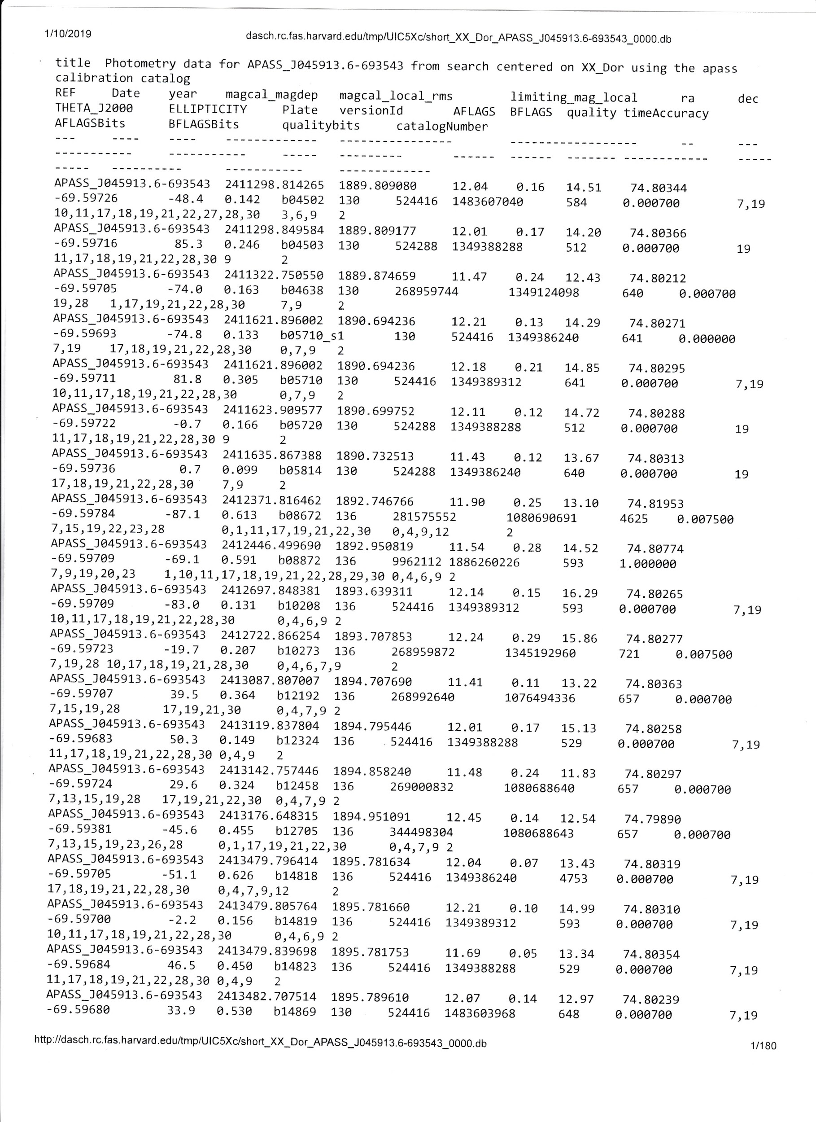
In VStar, to use this plugin, select “New Star from DASCH file …” from the File menu. The plugin will display a dialog box, asking you to select a file or input a full URL. The DASCH data will then become available in VStar for analysis.

In the DASCH data, some of the observations show a “magErr” of 99, indicating that the observed magnitude lies beyond the range of the limiting magnitudes for the original plates. The plug-in flags these observations as “excluded. For the above example, the initial plot looks like the following, somewhat distorted by the resultant large error bars.

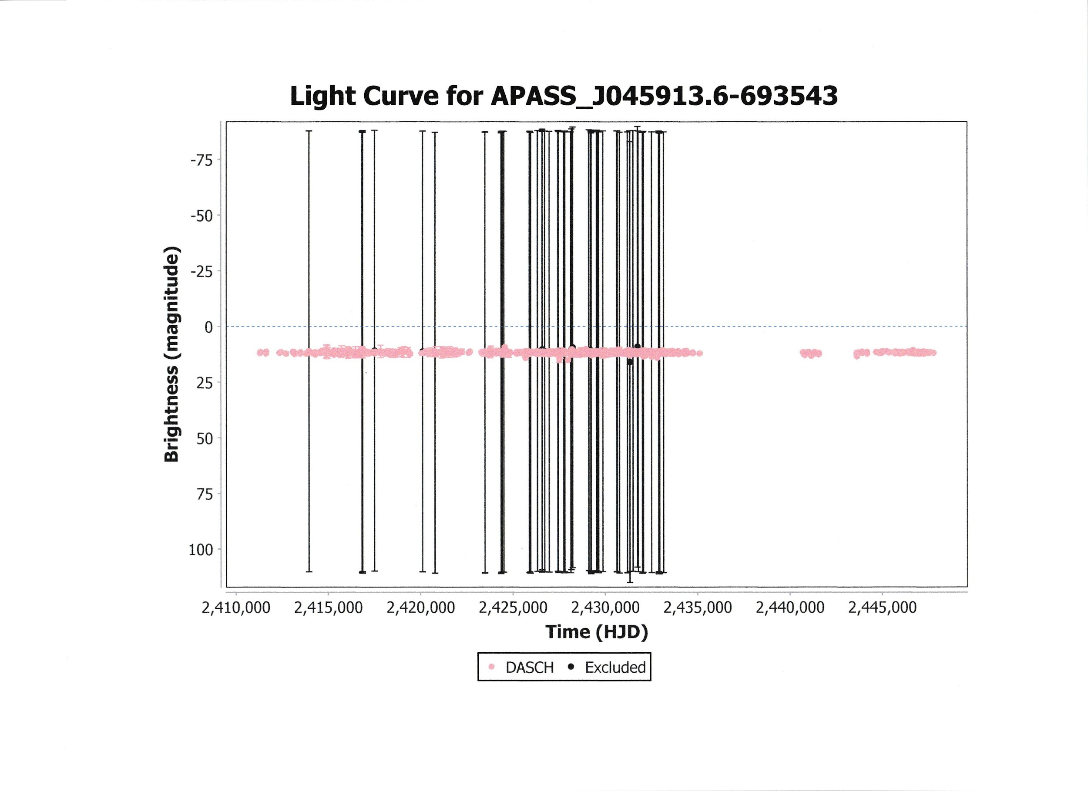
If you then select Plot Control from the View menu and un-check the “Excluded” box under Visibility of Data, the new plot will look much more “reasonable”.

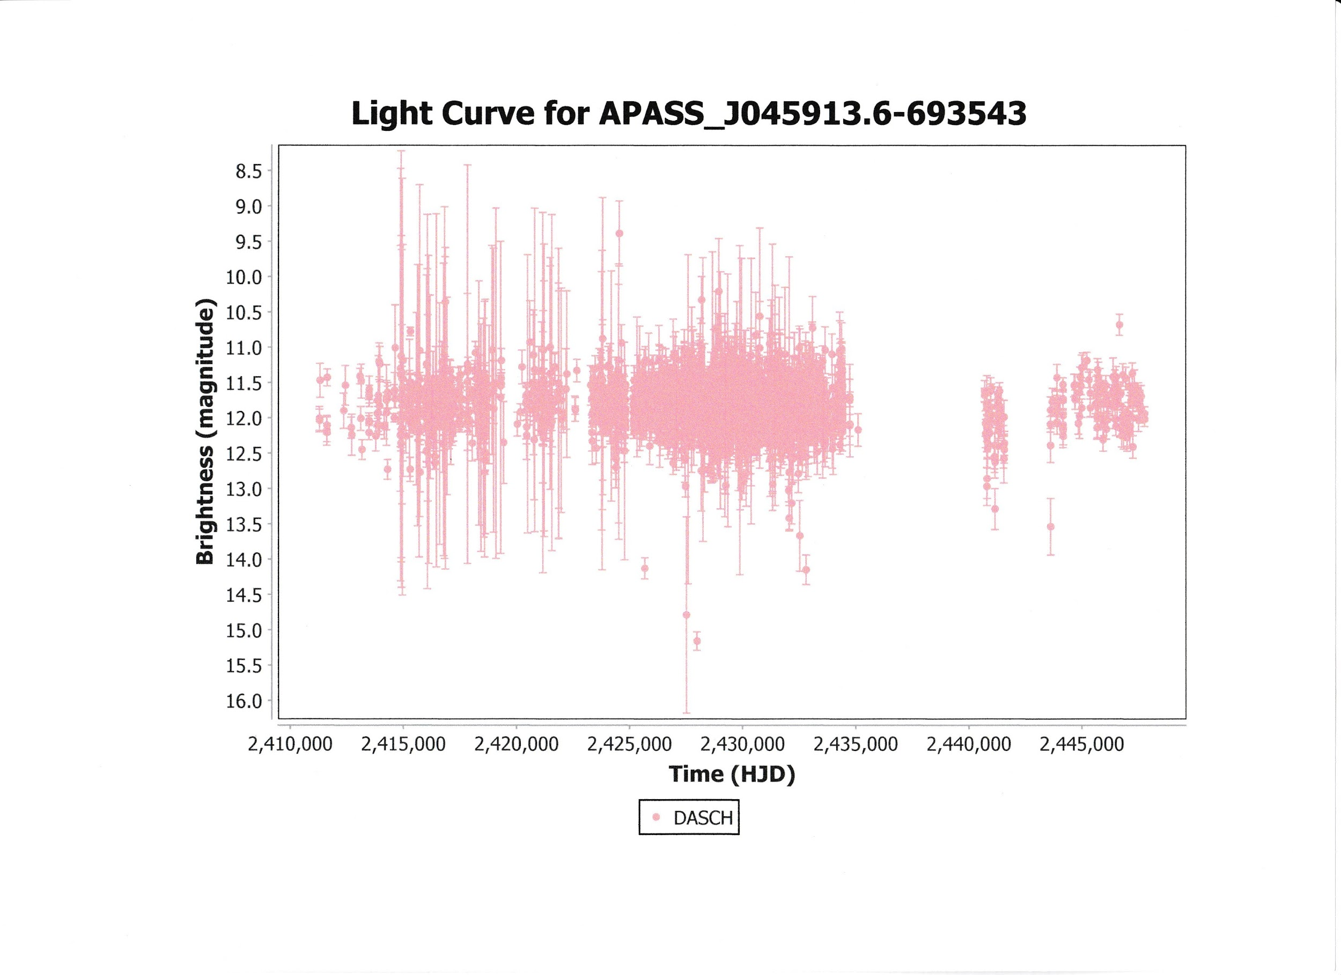
From there, a variety of analyses is available in VStar. For example, if period analysis is desired, go to the VStar Analysis drop down menu and select “DC DFT Standard Scan”. This will yield:
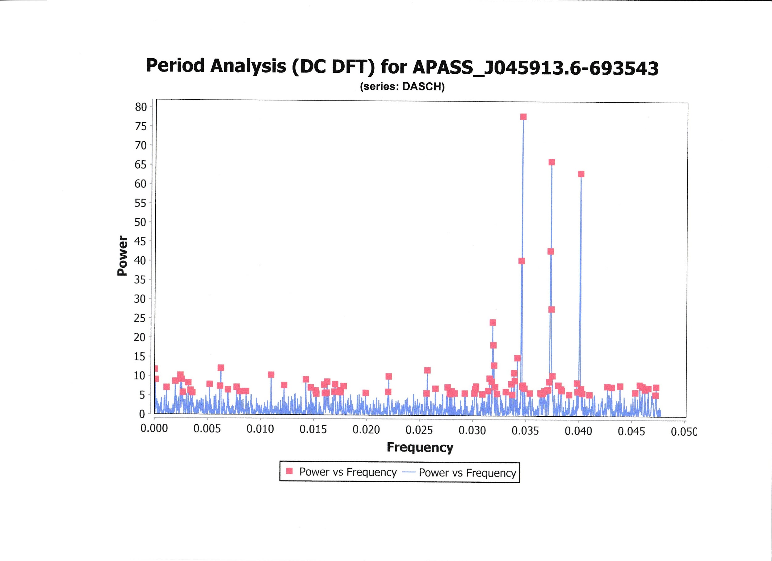
Selecting the “Top Hits” option will yield the following phase plot.



